Born in the USA:
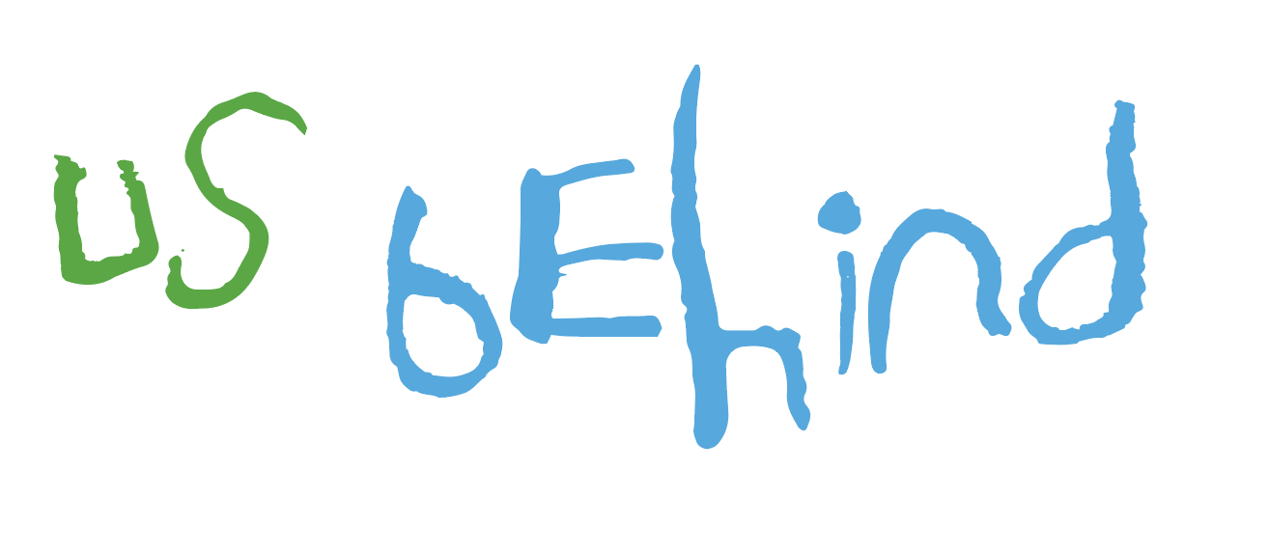
An #ActForEarlyYears policy brief

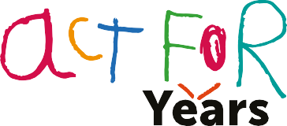
An #ActForEarlyYears policy brief
Theirworld September 2023

Born in the USA: An #ActForEarlyYears policy brief

Background

Each year approximately 3.6 million children are born in the United States. Investment in these young children during the first five years of their lives, especially when they come from marginalized backgrounds, is perhaps the most important intervention that can ever be made – at the local, state and federal level – with long-lasting benefits for society and the economy.

For a child, the first five years are a once-in-a-lifetime opportunity. This is when 90% of brain development occurs and patterns of learning and behavior are set for the future.
Unfortunately, this opportunity is being wasted for so many children on a national and global scale. When children are too young to voice their own opinion or stand up for themselves, the social safety net and general early years investment needed to ensure that every child everyone has an equal chance at the American dream are simply not in place. The result is a widening of the inequality gap and a failure to develop children’s full potential.

This truly amounts to a crisis in early years’ care and provision. The high cost or poor availability of adequate childcare is a major reason why women and primary caregivers leave their jobs, which means their families are less able to afford all the things that their children need. When children who have not received quality care or preschool start elementary school, they are at a disadvantage compared to children who have benefited from some level of early learning.

The State of the Early Years in 10 Statistics

Here is the state of early childhood development in ten statistics, to help show America is faring in acting for the early years.

- Childcare in the U.S. is becoming unaffordable. A survey for Theirworld found that:
- more than one in four parents (27%) have quit a job or dropped out of education to avoid the soaring cost of childcare
- 59% said their childcare expenses have increased in the last six months
- 42% of Gen Z parents (aged 18-24) said they spent between 30% and 70% of their income on childcare

- Childcare creates stress in families and affects major household decisions.
The survey also showed that:
- more than two-thirds of parents in the U.S. (68%) said they find it difficult to meet childcare costs
- two in three parents (66%) have made major financial changes to make ends meet.

America invests less than most major countries on early childhood care and education. In fact, it ranks 34th out OECD countries, behind countries like Mexico, Colombia, Hungary, and the EU as a percentage of GDP.

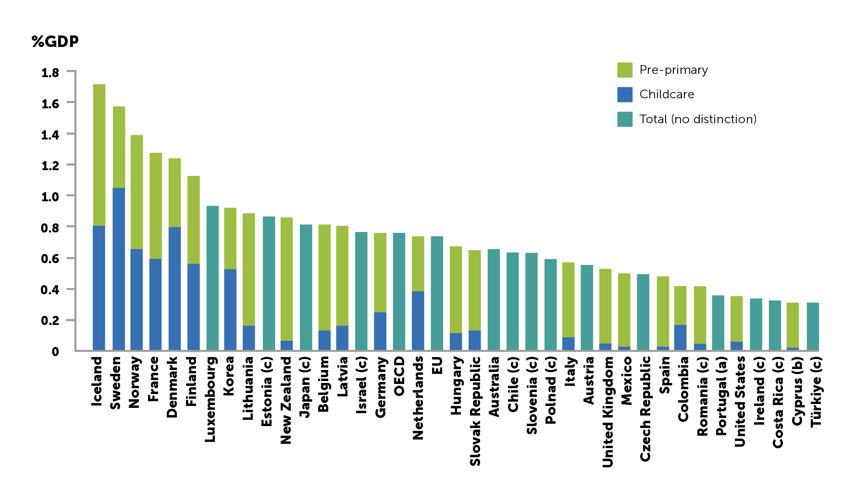
Stacked bar chart displaying public expenditure on childcare and pre-primary education and total public expenditure on early childhood education and care for various countries as a % of GDP, 2019 or latest available. Source: OECD.

- America leaves behind half of its talent pool and human potential before the age of five. Only half of three- and four-year-old children are enrolled in preschool. These critical years help equip young people with the essential skills they will need to learn and thrive in society.

- The early years profession is not valued. The average annual salary of a childcare provider in the U.S. is $29,570 (or $14.22 per hour). Alabama, Louisiana, Mississippi, and West Virginia have the lowest average pay of less than $11 per hour; the total salary is below the poverty line for a family of three with a single wage earner. California, Massachusetts and the District of Colombia have the highest average pay at $18 or more per hour.
- U.S. states don’t spend enough on preschool or other childhood development services. U.S. states spend an average of $6,571 on preschool education per child. The estimated annual national average cost (in 2020 dollars) of full day high quality preschool was $12,500 per child for a 180-day school year, about $4,500 higher than the current average.
The number is even more shocking when compared to spending on incarceration. The federal government spent $39,158 on each federal inmate in a federal facility during fiscal year 2022. In 2021, federal government spending on children spiked with pandemic relief efforts, reaching $10,710 per child (health spending, early education, social services, training, nutrition, and income security programs, etc. combined) – about 25% of that spent on incarceration. Several studies have linked preschool effects to arrests later in life. ,
- U.S. learning levels are on a downward spiral. Learning in the U.S. is at an all-time low. Only 26% of American children are proficient in math and only a third in reading. Similarly U.S. history skills have declined for 10 years and civics have declined for the first time ever. Investing in foundational skills in the early years can lay a strong foundation to unlock learning later in life.
- Companies can’t find youth with the skills they need because we fail to invest in the early years. Today, 45% of hiring managers have positions available but cannot find individuals with the relevant skills they need. The need for manual and physical skills, as well as basic cognitive ones, will decline, but demand for technological, social, and emotional, and higher cognitive skills will grow. Many of these skills developed and cultivated before the age of five.
- Prenatal care and child poverty is a concern. Approximately one baby is diagnosed with neonatal abstinence syndrome (NAS) every 24 minutes in the United States, having been exposed to harmful toxins such as opioids or alcohol. The number of babies born with NAS increased by 82% nationally from 2010 to 2017 across nearly all states and demographic groups. One in six children under 5 (3 million children) were poor, the highest rate of any age group. With the evidence suggesting 50% of a child’s development is impacted by nurture, it is essential that young children, especially from disadvantaged backgrounds, have as much support as possible.

- U.S. federal law fails to provide a right to paid family or medical leave when a family has a child. While there have been some advancements, such as parts of the recent Build Back Better Act, only 11 states have passed paid family and medical leave laws: California, Colorado, Connecticut, Delaware, Massachusetts, Maryland, New Jersey, New York, Oregon, Rhode Island, and Washington state, along with Washington D.C. New Hampshire’s and Vermont’s governors provide a voluntary opportunity to purchase insurance coverage.

The Case for Supporting the Early Years in the United States

Investing in the early years is a smart investment. Children who receive early childhood development interventions are more likely to excel later in life.

While some of the initial benefits of a preschool-only approach in federal preschool programs has been thought to dissipate by grade three, the impact of intensive interventions is undeniable. A study examining the impact of intensive interventions before the age of five found children are four times likelier to graduate from college, five times less likely to have been on public assistance, have significantly reduced chances of being arrested or charged with a crime, and significant improvements in adult math and reading ability. Others found that children who attend public preschool are more likely to attend college.

But the impact goes beyond educational attainment – investing in the early years drives economic growth. One study found that targeted preschool and childcare programs could increase U.S. GDP by 0.1 percent, even if deficit funded, by 2051.

It can help more women enter the American workforce and close the gender pay gap. Women are paid on average 22% less than men and 46% of mothers who remain unemployed left the workforce in 2021 due to childcare issues.

It saves taxpayers money and makes communities safer. One study showed a 7% to 10% per year return on investment based on increased school and career achievement as well as reduced costs in remedial education, health and criminal justice system expenditures.

Financial commitment to the early years also has the potential to create thousands of new jobs. There are currently 100,000 fewer childcare workers than there were before the pandemic. It is estimated that there will be 170,000 openings for childcare workers each year until 2031.

A blueprint to act for the early years

Acting for the early years requires prioritization and coordination at all levels of government – local, state and federal – to deliver the programs, people and public spending necessary to provide every child with the best start in life.

Programs
Every child and family should be able to access a comprehensive high-quality program of support from pregnancy to five years old. As a first step, each state and county should map its programs to make access as straightforward as possible for families in the prenatal stage or with young children to access services and programs.

The programs should include the five proven intervention packages of support addressing:
- Family support
- Pregnancy
- Healthy birth
- Child health and development
- Preschool (starting at age three).

The Child Trends Prenatal-to-Three work conducted in Allegheny County, PA with the support of the Heinz Foundation and the Birth to Five Illinois Early Childhood Regional Needs Assessments, are examples of the type of information which could form the foundation for mapping services across a region.

People
Governments must invest in a fully trained, qualified, and fairly paid early years workforce. This includes expanding skill-building courses for childcare and other careers and ensuring livable wages in the profession to incentivize a greater supply of committed, quality caregivers.

Investment in the early years also includes putting the right people in administrative posts to coordinate provision and delivery. The federal government should consider establishing an early childhood czar to coordinate policy across all agencies. Each state should consider appointing a similar coordinator to link spending and action across the state in coordination with county-level coordinators focused on cohesive and seamless service delivery.

Public Spending
Building on assessments by UNICEF and others documenting the skewed public investment in late adolescence, governments should front-load public spending on children and youth to children aged 0-5 where it has the most long-term impact. Providing for children in their early years must be treated as a public good vital for a country’s economic growth and productivity, not a private test of a family’s financial strength.

It requires investment at the federal, state and local levels and partnership with private sector employers as partners to deliver last-mile services for employees and communities. As the burden of provision still falls heavily on families, targeted tax credit can prove beneficial in incentivizing service delivery for the early years.

US global leadership on the early years

Here are three ways in which US foreign policy leadership on the early years could have a significant impact in taking a renewed national commitment to the 0-5s global, helping children around the world:

- Advocate that the G20 chaired by Brazil in 2024 and South Africa in 2025 commits to review and revitalize its Early Childhood Development Initiative and set measurable international targets on the delivery of early years quality programs, investment in people and public spending.
- Work with development banks to help write-off debt – and debt-servicing costs – when indebted countries commit to reinvest these funds into public services for young children.
- Along with a group of champion countries, lead efforts towards a Global Summit for Early Years in 2025 to drive a transformation in support for the youngest and most marginalized children around the world.

Conclusion

Not only is the current situation for America’s youngest children unfair and deepening inequality at an early age, the lack of investment in the early years is costing the country financially, fueling unemployment, eroding our long-term safety, and reducing our overall global competitiveness.

The solutions exist to improve health, care, and education for the under-fives in the U.S. And so are the resources. What is missing to date is the required vision and across-the-board commitment to the early years.

This policy brief aims to summarize the mounting evidence asserting the case for a dramatic shift in priorities that will put the first five years of a child’s life on a par with primary, secondary and higher education. Only then will we give every child in the U.S. the best possible start in life and the best possible opportunity of a healthy, stable, and rewarding future.

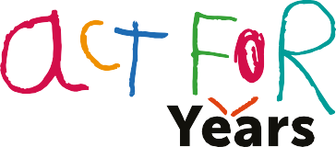

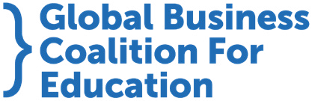

Established in 2002 and headquartered in London, United Kingdom with projects and campaigns reaching more than 100 countries around the globe, Theirworld is a UK-registered charity (1092312).
Theirworld USA is a registered 501(c)(3) organization in the United States and creates awareness, raises financial resources, and takes action to end the education crisis in the U.S. and around the world.

www.theirworld.org

Centers for Disease Control and Prevention. Births and Natality. 2021. Available Online: https://www.cdc.gov/nchs/fastats/births.htm
Theirworld. The Act for Early Years Report. 2023. Available online: https://theirworld.org/news/soaring-cost-of-childcare-forces-parents-to-make-tough-choices/
Theirworld. The Act for Early Years Report. 2023. Available online: https://theirworld.org/news/soaring-cost-of-childcare-forces-parents-to-make-tough-choices/
U.S. Department of Commerce, Census Bureau, Current Population Survey (CPS), October, 2010 through 2021. See Digest of Education Statistics 2022, table 202.20. In 2021, 50% of 3– to 4-year-olds were enrolled in preschool. This number plummeted to 40% in 2020 due to the pandemic. It peaked at 55% in 2013. Available online: https://nces.ed.gov/programs/digest/d22/tables/dt22_202.20.asp
U.S. Bureau of Labor Statistics. Standard Occupational Classification. 2018. Available online: http://www.bls.gov/soc/home.htm
U.S. Department of Health and Human Services. Poverty Guidelines. 2022. Available online: https://www.acf.hhs.gov/sites/default/files/documents/ocs/CED-HHS-Poverty-Guidelines-2022.pdf
The National Institute for Early Education Research. The State of Preschool. 2022. Available online: https://nieer.org/wp-content/uploads/2023/05/YB2022_ExecutiveSummary.pdf
The National Institute for Early Education Research. The State of Preschool. 2020. Available online: https://nieer.org/wp-content/uploads/2021/04/YB2020_Full_Report.pdf
Federal Register. Annual Determination of Average Cost of Incarceration Fee (COIF). 2021. Available online: https://www.federalregister.gov/documents/2021/09/01/2021-18800/annual-determination-of-average-cost-of-incarceration-fee-coif
Urban Institute. Kids’ Share 2022: Report on Federal Expenditures on Children through 2021 and Future Projections. 2022. Available online: https://www.urban.org/sites/default/files/2022-10/Kids’%20Share%202022%20Report.pdf
National Library of Medicine. Preschool Education, Educational Attainment, and Crime Prevention: Contributions of Cognitive and Non-Cognitive Skills. 2009. Available online: https://www.ncbi.nlm.nih.gov/pmc/articles/PMC5031146/
Council for a Strong America. Police Chiefs, Sheriffs, Prosecutors, and Violence Survivors: “Preschool Works.” 2021. Available online: https://strongnation.s3.amazonaws.com/documents/1408/10dcce36-0330-4efc-8999-99dd46bc58f4.pdf?1634248017&inline;%20filename=%22Police%20Chiefs,%20Sheriffs,%20Prosecutors,%20and%20Violence%20Survivors:%20%E2%80%9CPreschool%20Works%E2%80%9D.pdf%22
National Center for Education Statistics. NAEP Report Card: 2022 NAEP Mathematics Assessment. 2022. Available online: https://www.nationsreportcard.gov/highlights/mathematics/2022/
National Center for Education Statistics. The NAEP 2023 Long-Term Trend Age 13 Highlights Report. 2023. Available online: https://nces.ed.gov/nationsreportcard/
Express Employment Professionals. The Harris Poll. 2022. Available online: https://www.expresspros.com/Newsroom/America-Employed/Labor-Shortage-and-Employee-Turnover-and-Benefits-Demands-Keeping-Employers-Up-at-Night.aspx
Centers for Disease Control and Prevention. Data and Statistics. 2023. Available online: https://www.cdc.gov/pregnancy/opioids/data.html#:~:text=Neonatal%20Abstinence%20Syndrome&text=That%20is%20approximately%20one%20baby,59%20newborns%20diagnosed%20every%20day
Children’s Defense Fund. The State of America’s Children. 2023. Available online: https://www.childrensdefense.org/the-state-of-americas-children/soac-2023-child-poverty/#:~:text=11%20million%20children%20live%20in,from%20the%20highest%20poverty%20rates
The University of Queensland. Nature v nurture: research shows it’s both. 2015. Available online: https://qbi.uq.edu.au/article/2015/05/nature-v-nurture-research-shows-it%E2%80%99s-both
Center for American Progress. The State of Paid Family and Medical Leave in the U.S. in 2023. 2023. Available online: https://www.americanprogress.org/article/the-state-of-paid-family-and-medical-leave-in-the-u-s-in-2023/
Office of Planning, Research, and Evaluation, Administration for Children and Families, U.S. Department of Health and Human Services. Third Grade Follow-up to the Head Start Impact Study: Final Report. 2019. Available online: https://www.acf.hhs.gov/opre/report/third-grade-follow-head-start-impact-study-final-report
Social Programs That Work. Abecedarian Project. 2017. Available online: https://evidencebasedprograms.org/programs/abecedarian-project/
Massachusetts Institute of Technology. Study: Preschool gives a big boost to college attendance. 2023. Available online: https://news.mit.edu/2023/study-preschool-gives-big-boost-college-attendance-0208
The Wharton School of the University of Pennsylvania. Economic Effects from Preschool and Childcare Programs. 2021. Available online: https://budgetmodel.wharton.upenn.edu/issues/2021/8/23/economic-effects-preschool-and-childcare-programs
Economic Policy Institute. Low-wage workers have seen historically fast real wage growth in the pandemic business cycle. 2023. Available online: https://www.epi.org/publication/swa-wages-2022/
Heckman. Invest in Early Childhood Development: Reduce Deficits, Strengthen the Economy. Available online: https://heckmanequation.org/resource/invest-in-early-childhood-development-reduce-deficits-strengthen-the-economy/
The New York Times. Why You Can’t Find Child Care: 100,00 Workers Are Missing. 2022. Available online: https://www.nytimes.com/2022/10/13/us/child-care-worker-shortage.html#:~:text=The%20shortage%20is%20contributing%20to,the%20Bureau%20of%20Labor%20Statistics
U.S. Bureau of Labor Statistics. Childcare Workers. 2022. Available online: https://www.bls.gov/ooh/personal-care-and-service/childcare-workers.htm#:~:text=Job%20Outlook,-Employment%20of%20childcare&text=About%20170%2C100%20openings%20for%20childcare,force%2C%20such%20as%20to%20retire
The World Bank. Report: Stepping Up for Early Childhood Development. 2014. Available online: https://www.worldbank.org/en/topic/earlychildhooddevelopment/publication/stepping-up-early-childhood-development
Child Trends. Prenatal-to-Three in Allegheny County. 2023. Available online: https://doi.org/10.56417/5779f5179g
Birth to Five Illinois. Elevating the voices of families and providers to improve early childhood programs in Illinois. 2022. Available online: https://www.birthtofiveil.com/about
UNICEF. Too Little, Too Late: An Assessment of public spending on children by age in 84 countries. 2023. Available online: https://www.unicef-irc.org/publications/pdf/Too_Little_Too_Late_Report.pdf

