

**A diminished priority**

**An updated scorecard on donor   
funding to pre-primary education during Covid-19**

Prepared for Theirworld by Asma Zubairi and Pauline Rose of the Research for Equitable Access and Learning (REAL) Centre, University of Cambridge

**May 2023**



# Contents

Introduction 3

Key Messages 5

Trends in aid to pre-primary education during Covid-19 7

Largest donors to pre-primary education 12

Largest recipients of pre-primary aid 16

Endnotes 27

Prepared for Theirworld by

Asma Zubairi and Pauline Rose

of the Research for Equitable

Access and Learning (REAL) Centre

University of Cambridge.

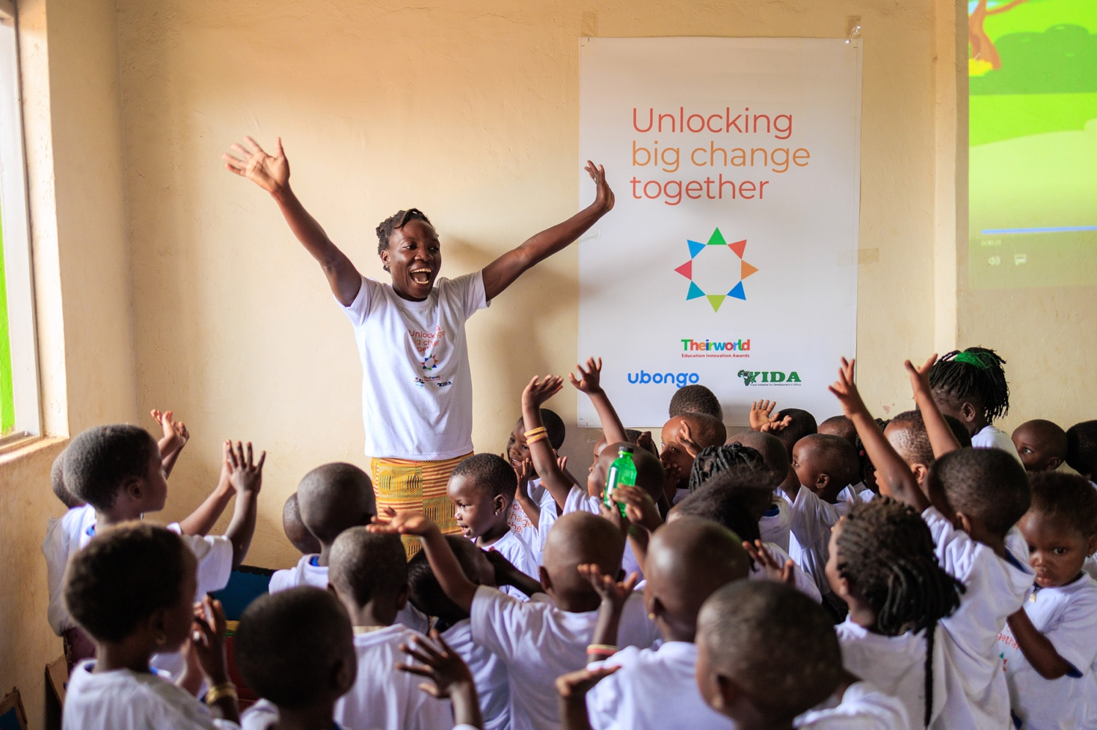

Image on page 3

Image credit: Theirworld / Mara Mambo Media

A teacher leading a group of children in song.

# Introduction

This is the sixth report in a series dating back to 2017 by the Research for Equitable Access and Learning (REAL) Centre for Theirworld. The series identifies donor performance in pre-primary education, with the latest report focusing in particular on the period from 2020 to 2021, the two years most severely affected by Covid-19.

As with our previous reports, this report is based on the widely-recognised understanding that investing in the early years is vital for young children’s futures. As evidence has shown, quality interventions in pre-primary education are a highly effective investment for individuals and societies, with up to 90% of a child’s brain development taking place between birth and the age of five.

In recognition of this, since 2017 Theirworld has been advocating for aid donors and national governments to commit 10% of their education spending to early childhood education. In 2017, UNICEF took up this pledge. There was wider recognition of this target in 2022, when 147 United Nations member states signed up to the *Tashkent Declaration and Commitments to Action for Transforming Early Childhood Care and Education,* which included a commitment to spending 10% of education budgets on pre-primary education.

However, just as the pandemic resulted in millions of young children missing out on vital care and learning, we find that pre-primary education was particularly adversely affected by the cut in aid funding at this time. This is likely to have longer-term repercussions.

An opinion survey conducted for Theirworld in seven countries across a range of income levels in March 2023 found that on average [a quarter of parents](https://theirworld.org/news/soaring-cost-of-childcare-forces-parents-to-make-tough-choices/) had given up work or education to pay for childcare (Theirworld, 2023).

In this context, Theirworld has launched the [Act For Early Years](https://actforearlyyears.org/) campaign, in order to raise awareness of what is – and has been for some time - a global crisis in the delivery of all early years services – childcare, education, health, safety and security - and to call for a global reset in how the world’s youngest children are supported.

A major challenge remains to the international community. In 2018, the G20 made ground-breaking commitments to early childhood development, stating that “investment in early childhood development, without any discrimination, should be a high priority”.

Yet 175 million children are still not enrolled in pre-primary education. Children born at the time of those promises will already have missed out on quality early childhood development.

The G20 needs to review and revitalise its commitments to the early years, beginning with its meeting in September 2023 in New Delhi.

The same is true for the whole international community if the pledge contained in Sustainable Development Goal target 4.2, that “by 2030 every girl and boy should have access to quality early childhood development, care and education”, is to be fulfilled.

For every child, wherever they live, investment in the early years, including pre-primary education, is a once-in-a-lifetime opportunity. It is our duty to ensure they are not wasted.

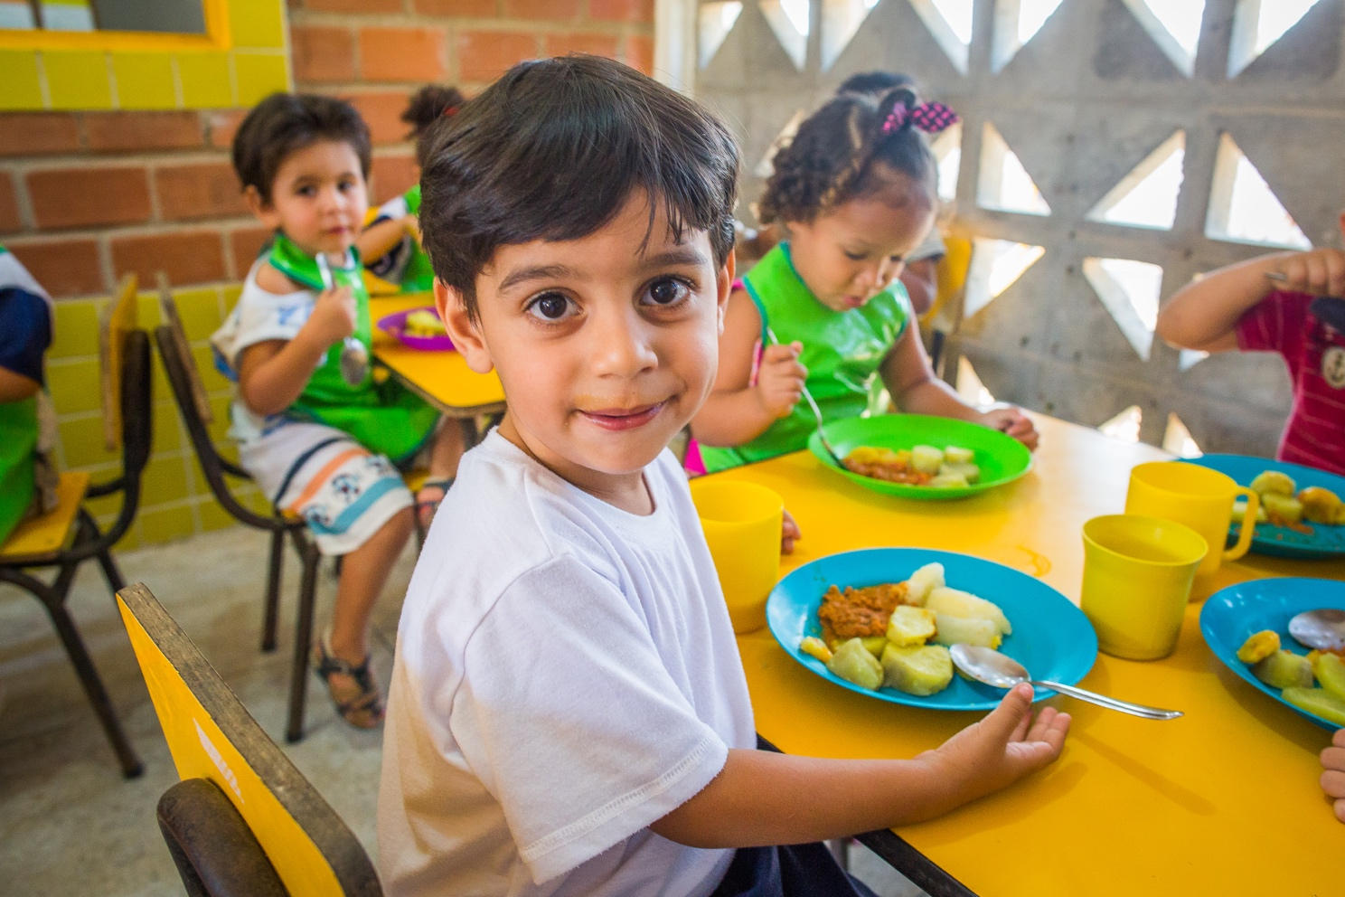

Image on page 5

Image credit: UNICEF/Raoni Libório  
Child eats a balanced and nutritional lunch at an early years centre in Brazil.

# Key messages

**During the peak of the Covid-19 pandemic from 2020 to 2021, aid spent on pre-primary education fell by a greater proportion than aid to education overall.** The amount of aid to pre-primary education fell from $209 million in 2020 to $189.3 million in 20211, a 9.4% decrease – compared with a 6.9% decline in education aid overall. This was the first decline since 2017.

**The large decrease in aid to pre-primary education is against a backdrop of a small decline in overall aid.** Total aid decreased by 0.9% from 2020 to 2021, a much smaller amount than aid to education, and to pre-primary education in particular. During this period, aid to the health sector increased substantially, by 27.9%, largely due to spending directly related to COVID-19. In 2021, aid expenditure related to Covid-19 made up 37.3% of aid spending on health.

**Aid to pre-primary education has moved further away from the 10% target.** Since 2017 Theirworld has been advocating for aid donors and national governments to commit 10% of their education spending to early childhood education. The disproportionate reduction in aid to pre-primary education means the share of education aid spent on pre-primary education fell to an even smaller proportion, from 1.2% in 2020 to 1.1% in 2021.

**Among the top 35 donors to education, only two donors have met the 10% target.** UNICEF continues to provide strong prioritisation to pre-primary education, with a share of 30% in 2021. Italy’s prioritisation has increased dramatically to 18.8%, due in large part to its funding of pre-primary education in Jordan.

**Aid spending on post-secondary education far outweighs spending on pre-primary education.** In 2021, aid spent on post-secondary education was 27 times higher than pre-primary education. Aid spent on students from aid recipient countries studying in higher education institutes in donor countries was 21 times higher than the amount donors spent on pre-primary education.

**Aid to pre-primary education continues to be concentrated among a small number of donors, leaving it vulnerable to any shifts in donor priorities.** In 2021 the top five donors were responsible for over three-quarters of total pre-primary aid. The remaining quarter was spent by 28 donors, with half of these spending less than $1 million on pre-primary education.

**Spending on pre-primary education continues to be concentrated on lower-middle income countries:** In 2021, 15% of aid to pre-primary education was disbursed to low-income countries. This compares to 52.7% to lower-middle-income countries. Eritrea and Sudan were two low-income countries receiving no pre-primary education aid in 2021.

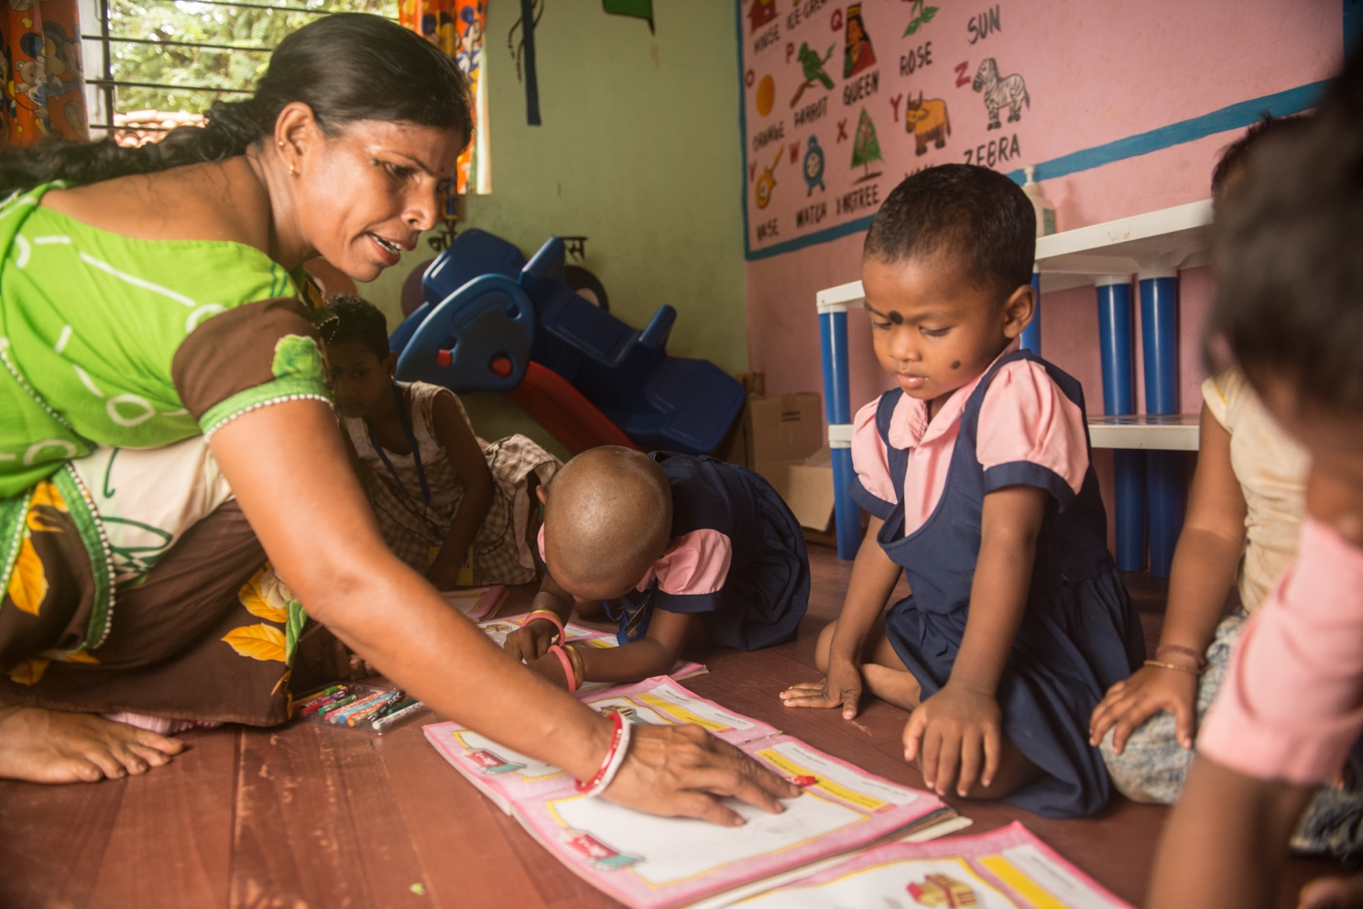

Image on page 7

Image credit: UNICEF  
Children are engaged with colourful books and toys at a centre in Jharkhand, India.

# Trends in aid to pre-primary education during the Covid-19 period

**Global trends**

In this paper, we review the latest data available on pre-primary education spending, with particular attention paid to trends in 2020 and 2021, when education systems were adversely affected by the Covid-19 pandemic. During this period, there is evidence that pre-primary education was not a priority in countries’ plans to cope with and recover from Covid [(Kim et. al., 2022)](https://www.sciencedirect.com/science/article/abs/pii/S0883035521001609). As we show in this report, this lack of prioritisation is reinforced by the trends in aid to pre-primary education.

**Global aid levels fell between 2020 and 2021 with the pre-primary education sector disproportionately affected by cuts.** Between 2020 and 2021 global aid disbursements fell by 0.9% from $224.2 billion to $222.2 billion. Total aid to education fell by 6.9%. Aid spending on health, by contrast, increased by 27.9% over the same two-year period. In 2021, aid expenditure related to Covid-19 accounted for 37.3% spending on health. This was equivalent to 87.2% of the increase in health spending between 2020 and 2021.

**Between 2020 and 2021 aid spending on pre-primary education fell** **by 9.4%.** During this period, the volume of aid spent on pre-primary education fell from $209 million to $189.3 million (Figure 1). This was the first decline since 2017. This was largely due to the World Bank (International Development Association) – the second largest donor to education overall – whose spending on pre-primary education fell dramatically from $122.8 million to $70.7 million. This was primarily due to a decline in pre-primary education spending in sub-Saharan Africa, with Rwanda alone accounting for 78% of the decline. This resulted in a fall in its level of prioritisation of pre-primary education within its education spending from 7.4% to just 4%, reversing its previous upward trend. At the other extreme, Italy (a relatively small education donor overall) increased its spending on pre-primary education from $2.6 million to $38.2 million over the same period.

**Aid to pre-primary education decreased at a faster rate compared to education overall.** Overall aid to education decreased from $18.1 billion to $16.8 billion between 2020 and 2021, representing a 6.9% decline. The amount spent on pre-primary education decreased by a larger amount over the same period, by 9.4% from $209 to $189.3 million.

**Aid to early years’ education fell by a far larger proportion than aid to higher levels of education.** Similar to pre-primary education, aid to primary education also fell by a large amount, by 10.5%, while secondary education declined by 5.7% and post-secondary education was more protected, falling by 3.9% (Figure 2).

**The share of education aid to pre-primary education declined between 2020 and 2021.** As a result of the greater decline in pre-primary education aid spending during the pandemic, its share of education aid slightly decreased from 1.2% in 2020 to 1.1% (Figure 3). As such, aid spending has moved even further from therecommended Theirworld target of 10%, although this target was agreed by 147 United Nations member states who signed up to the *Tashkent Declaration and Commitments to Action for Transforming Early Childhood Care and Education*.

**Only two donors have reached the 10% target.** The latest data show that UNICEF and Italy were the only donors meeting the 10% target for pre-primary education spending. As well as the noted dramatic decline in the World Bank’s (IDA) share of education aid spending on pre-primary education from 7.4% in 4% in 2021, Finland, the United Kingdom and Norway have lowered the priority of their spending on pre-primary education within their wider education spending during this period (Figure 4).

**Donors give far greater prioritisation to post-secondary education than pre-primary education.** In 2021, aid spent on post-secondary education was 27 times more than spending on pre-primary education. With respect to the amount of aid spent on students from aid recipient countries studying in higher education institutes in donor countries, this was 21 times higher than the amount donors spent on pre-primary education.

**Figure 1: Pre-primary education aid spending declined from 2020 to 2021**

*Aid to pre-primary education, 2002 to 2021*

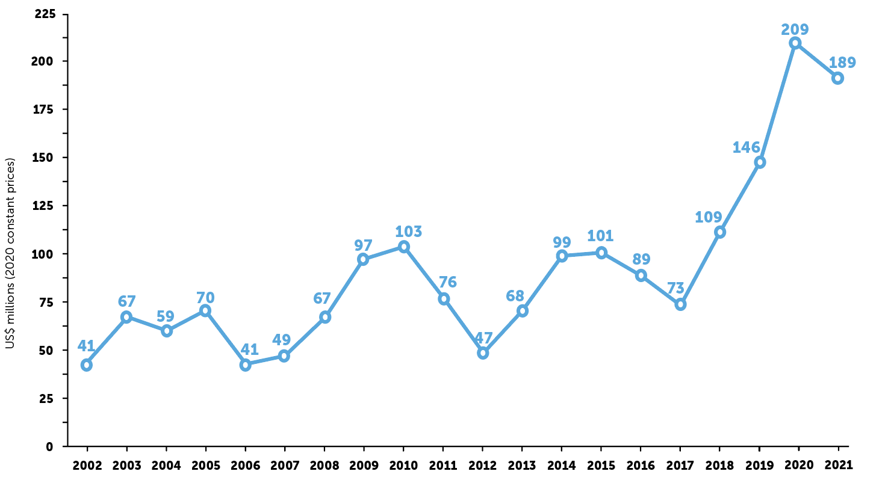

Source: Authors’ calculation based on OECD Creditor Reporter System. *Accessed March 2023.*

**Figure 2: Pre-primary education aid spending has remained a consistently low proportion of education aid spending**

*Aid to education by sub-sector, 2002 to 2021*

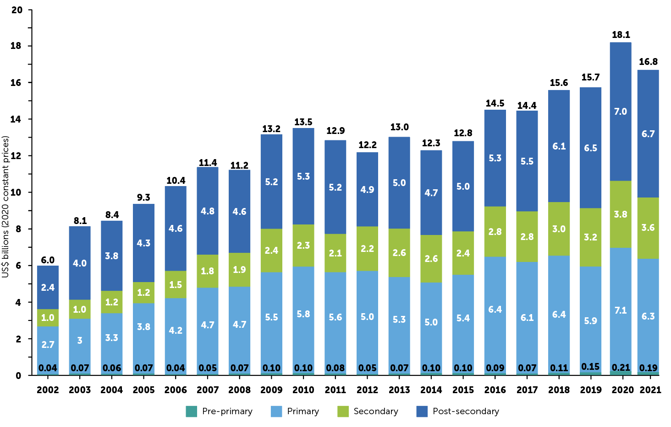

Source: Authors’ calculation based on OECD Creditor Reporter System. *Accessed March 2023.*

Note: GBS to education refers to the portion of total aid spent on General Budget Support that this report estimates was spent on education. For each donor, this report estimates that 20% of what is spent on GBS is spent on education.

**Figure 3: Share of education aid by sub-sector, 2020 and 2021**

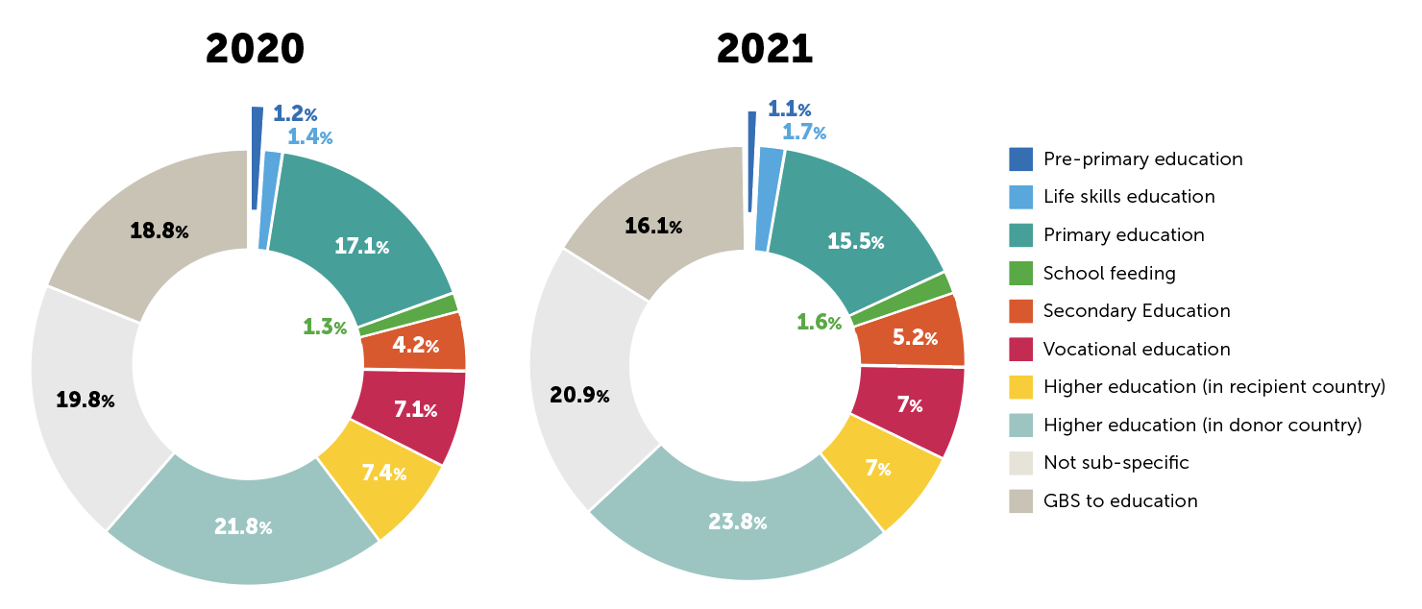

Source: Authors’ calculation based on OECD Creditor Reporter System. *Accessed March 2023.*

**Figure 4: UNICEF and Italy were the only donors who met the recommended target of 10% education spending to pre-primary education in 2021**

*Share of total education aid to pre-primary education, 2020 and 2021*

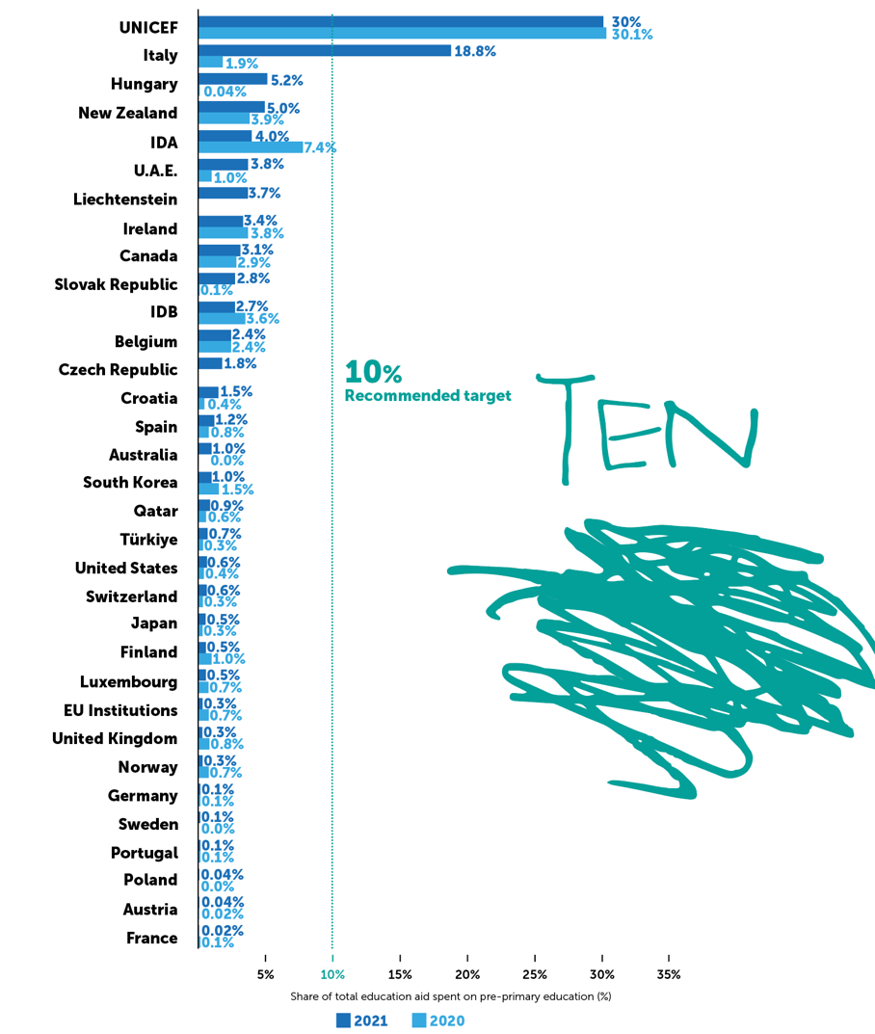

Source: Authors’ calculation based on OECD Creditor Reporter System. *Accessed March 2023.*

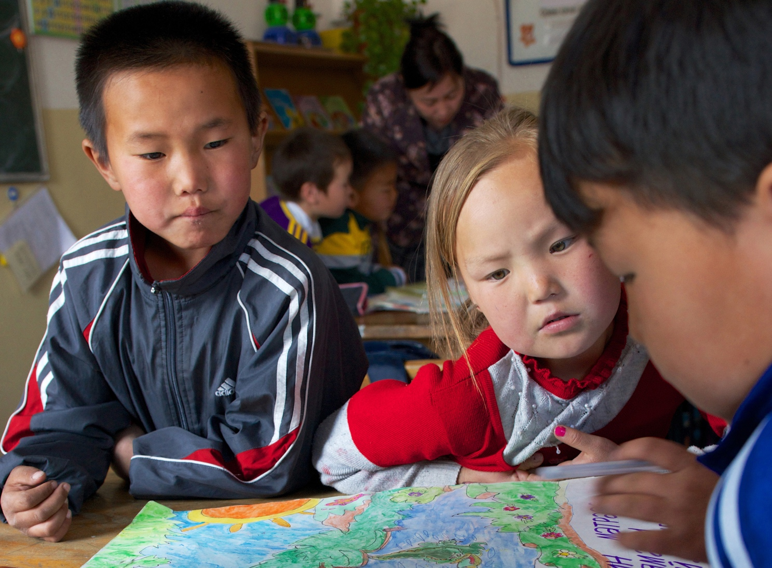

Image on page 12

Image credit: Khasar Sandag / World Bank   
Children in a kindergarten in Dadal County, Mongolia.

# Largest donors to pre-primary education

**Of the top 35 donors to education in 2021:**

* **Eight donors did not report any spending on pre-primary education.**These were: the African Development Bank (AfDB), Asian Development Bank (AsDB), Denmark, International Monetary Fund (IMF), Netherlands, Romania, Saudi Arabia and UNRWA. Apart from Denmark and Romania, none of these donors spent any aid on pre-primary education in 2020 either.
* **Of the remaining 27 donors, 13 increased their prioritisation to pre-primary education within their education portfolio between 2020 and 2021.** These included Italy, Hungary, U.A.E and New Zealand (Table 3).
* **Eight donors decreased the share of education aid spent on pre-primary education between 2020 and 2021.** These were: the World Bank (IDA), South Korea, Finland, Luxembourg, United Kingdom, Norway, EU Institutions and France.
* **Six donors kept the share of education aid spent on pre-primary education unchanged in 2020 and 2021.** These were: UNICEF, Germany, Portugal, Poland, Austria and Belgium.2

**Aid spending to pre-primary education continues to be concentrated among a small number of donors.** In 2021, the top five largest donors to pre-primary education (World Bank (IDA), Italy, UNICEF, United States and Canada) were responsible for just over three-quarters of the total aid spending on pre-primary education (Figure 5).

**In 2021, only six donors spent more than $5 million to pre-primary education.** These were Canada, Hungary, World Bank IDA, Italy, United States and UNICEF. Fourteen donors each disbursed less than $1 million to pre-primary education in 2021, reflecting a continued fragmented donor landscape (Figure 6).

**A large share of aid spent on pre-primary education in 2021 came from the G20 countries who will be participating in the G20 meeting in India in 2023.** G20 countries3 spent a total of $75.7 million on pre-primary education. This group spent 40% of the total reported aid spent on pre-primary aid in 2021. Their prioritisation to pre-primary education overall is extremely low, amounting to just 0.7% of their spending on aid to education. Of the 20 countries who are part of the G20 , 12 reported their spending to pre-primary education in 2021. The five G20 participants who spent the most aid on pre-primary education in 2021 were Italy, United States, Canada, EU Institutions and Japan.

**Figure 5: Pre-primary aid remains concentrated among a small number of donors**

*Share of top five donors to pre-primary education, 2021*

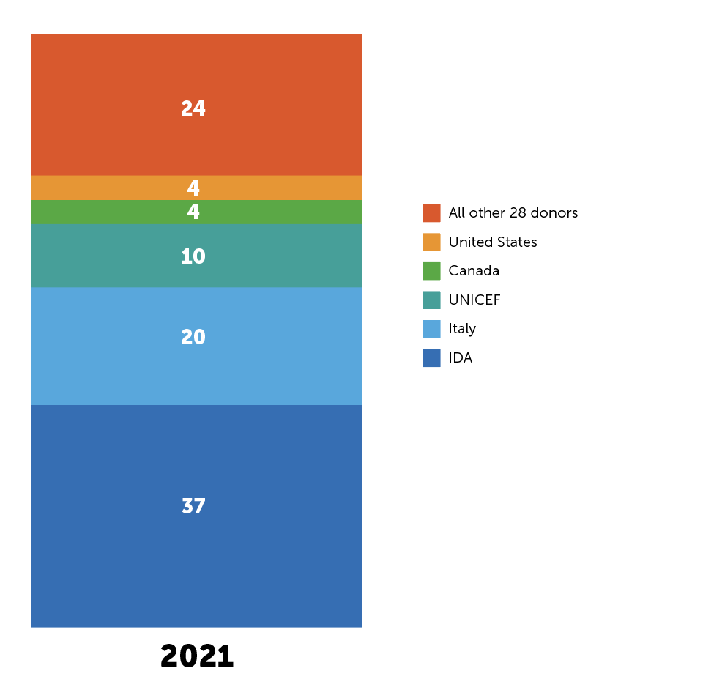

Source: Authors’ calculation based on OECD Creditor Reporter System. *Accessed March 2023.*

**Figure 6: The majority of donors spend very low amounts on pre-primary education**

*Fragmentation of pre-primary ODA, 2021*

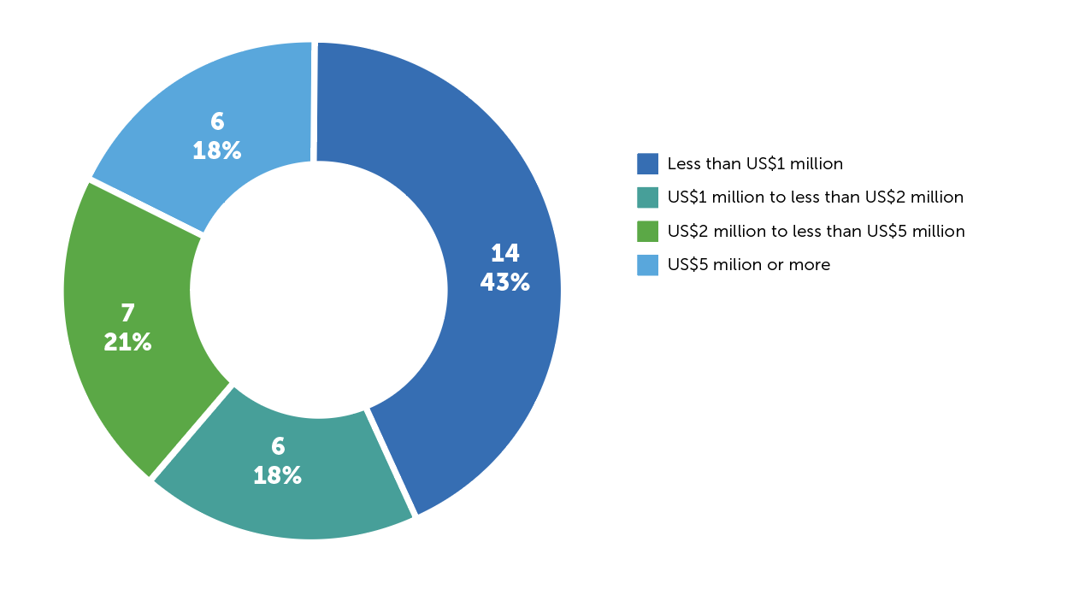

Source: Authors’ calculation based on OECD Creditor Reporter System. *Accessed March 2023.*

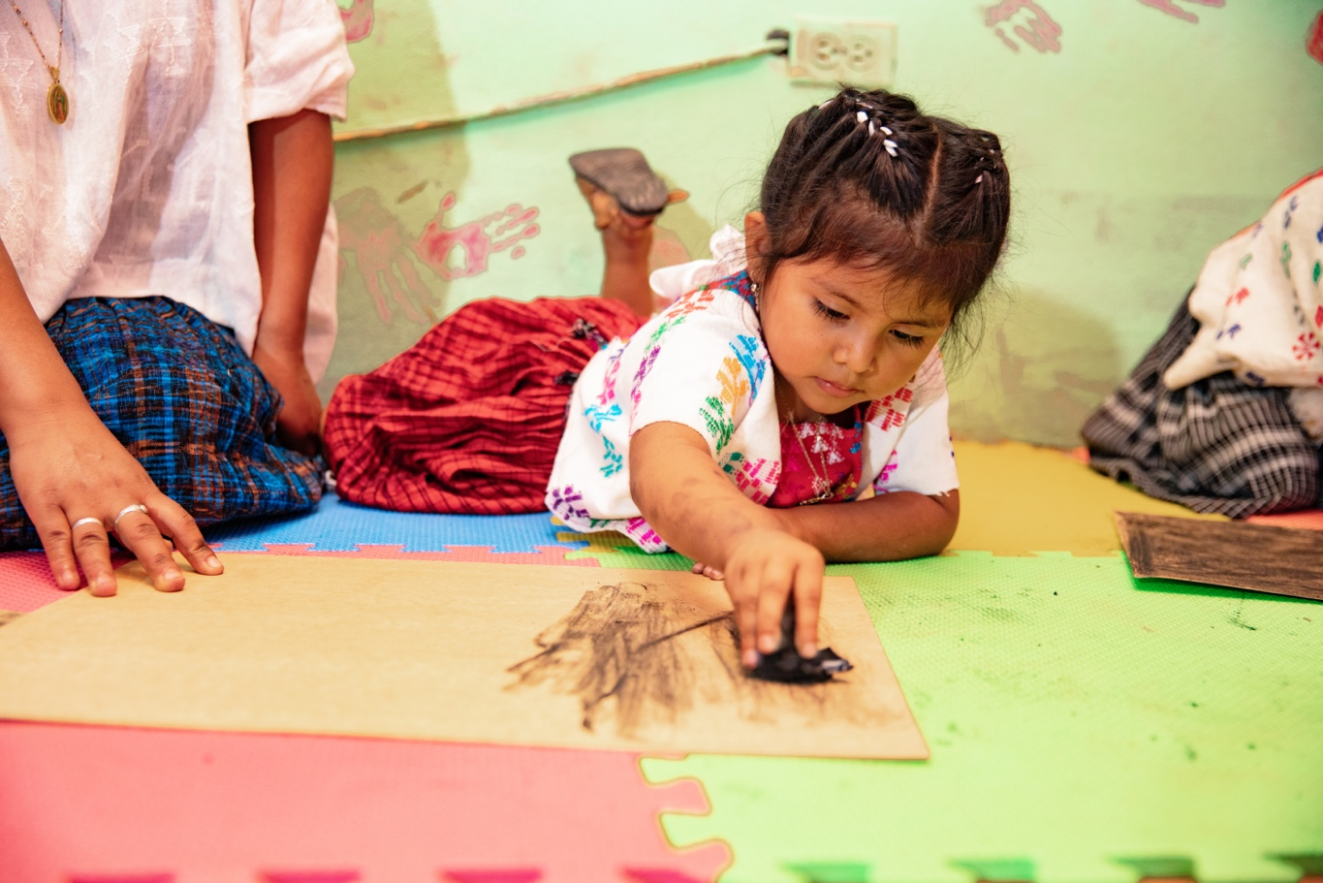

Image on page 16

Image credit: Khasar Sandag / World Bank   
A young girl plays while her mother participates in an early childhood development workshop in Guatemala.

# Largest recipients of pre-primary aid

**Aid spending to pre-primary education remains concentrated among a small number of recipients**. The top ten recipients of pre-primary education aid received 60% of the total by 2021 (Figure 7a). The geographical location of pre-primary education aid spending has shifted. In 2015, the East Asia & Pacific region received the lion’s share of pre-primary education aid spending overall (44%), largely because of the World Bank IDA’s support to Vietnam. By 2021 this had shifted to sub-Saharan Africa receiving almost half of pre-primary education aid, largely due to UNICEF’s support to this region (Figure 7b). Jordan was the largest recipient of aid to pre-primary education aid in 2021. This was primarily due Italy disbursing the bulk of its pre-primary education aid to Jordan (equivalent to $35.1 million). Tanzania, Ghana and Rwanda followed Jordan as the largest recipients of aid to pre-primary education in 2021.

**Middle-income countries continue to receive the lion's share of donor spending on pre-primary education.** The share of pre-primary education aid spent in low-income countries was just 15% in 2021, similar to the pre-primary school age population of 15 %. While this indicates equality in spending, it does not represent a progressive universalism approach, which expects greater resources to be provided to those countries most in need. The majority of pre-primary aid continues to be spent in lower-middle income countries, receiving 52.7% in 2021 compared with 43.4% of the pre-primary school-age population.

**Some of the world’s poorest countries receive very little or no aid to pre-primary education.** Of the 28 low-income countries, Eritrea and Sudan received no aid for pre-primary education in 2021. In addition, of the 120 countries receiving aid for pre-primary education, 114 countries received less than $5 per primary school-age child. Among these were the Central African Republic, Chad, Niger and Syria, which received less than 10 cents per child. Only six countries received more than $5 per child: Jordan, Tanzania, Rwanda, Ghana, Ukraine and Cameroon (Figure 8).

**Figure 7: Top recipients and regions of pre-primary aid, 2021**

1. *RecipientsA picture containing text, screenshot, circle, graphics

   Description automatically generated*

1. *Regions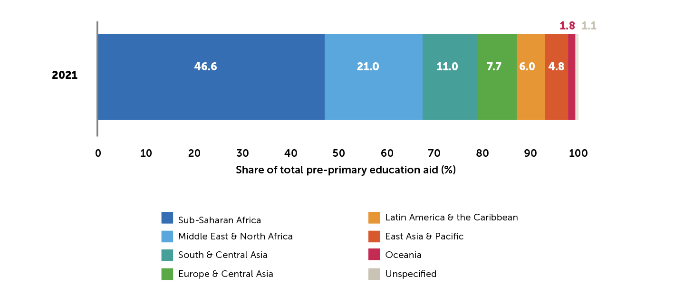*

Source: Authors’ calculation based on OECD Creditor Reporter System. *Accessed March 2023.*

**Figure 8: Pre-primary education aid per capita, 2021**

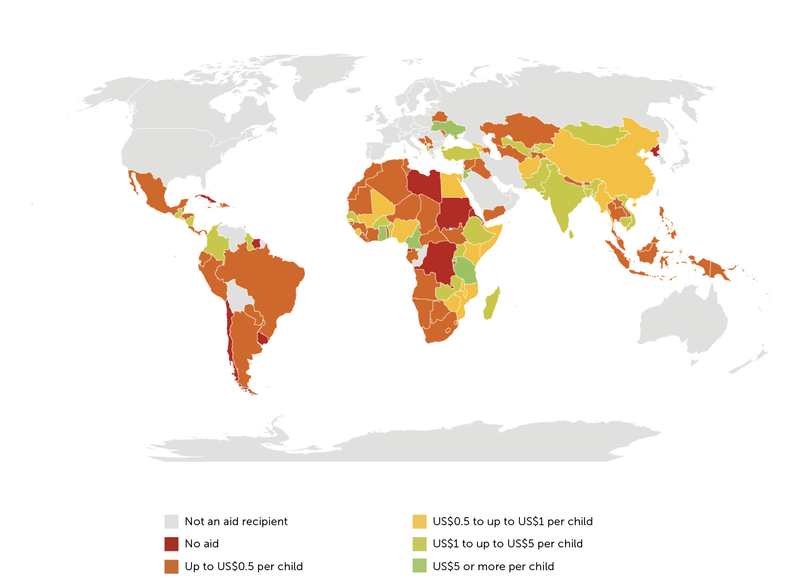

**Table 1: Top 35 donors to education, 2021**

|  |  |  |  |  |  |
| --- | --- | --- | --- | --- | --- |
|  | **Ranking by volume** | | **Pre-primary education aid** | | |
|  | Total education aid | Pre-primary aid | US$ millions (2020 prices) | Share of total pre-primary aid (%) | As a share of total education aid (%) |
| UNICEF | 32 | 3 | 19.7 | 10.4 | 30.0 |
| Italy | 15 | 2 | 38.2 | 20.2 | 18.8 |
| Hungary | 22 | 6 | 6.1 | 3.2 | 5.2 |
| New Zealand | 29 | 10 | 3.7 | 2.0 | 5.0 |
| IDA | 2 | 1 | 70.7 | 37.3 | 4.0 |
| U.A.E | 28 | 11 | 3.3 | 1.7 | 3.8 |
| Canada | 14 | 5 | 7.4 | 3.9 | 3.1 |
| Belgium | 24 | 12 | 2.7 | 1.4 | 2.4 |
| Spain | 31 | 19 | 0.8 | 0.4 | 1.2 |
| Australia | 17 | 14 | 2.0 | 1.0 | 1.0 |
| South Korea | 16 | 15 | 2.0 | 1.0 | 1.0 |
| Qatar | 21 | 17 | 1.1 | 0.6 | 0.9 |
| Türkiye | 11 | 13 | 2.5 | 1.3 | 0.7 |
| United States | 6 | 4 | 8.1 | 4.3 | 0.6 |
| Switzerland | 19 | 18 | 1.0 | 0.5 | 0.6 |
| Japan | 7 | 8 | 4.5 | 2.4 | 0.5 |
| Finland | 26 | 21 | 0.4 | 0.2 | 0.5 |
| Luxembourg | 35 | 23 | 0.2 | 0.1 | 0.5 |
| EU Institutions | 4 | 7 | 4.5 | 2.4 | 0.3 |
| United Kingdom | 9 | 16 | 1.8 | 1.0 | 0.3 |
| Norway | 12 | 20 | 0.8 | 0.4 | 0.3 |
| Germany | 1 | 9 | 4.3 | 2.3 | 0.1 |
| Sweden | 23 | 24 | 0.1 | 0.1 | 0.1 |
| Portugal | 34 | 27 | 0.1 | 0.03 | 0.1 |
| Poland | 20 | 26 | 0.1 | 0.03 | 0.04 |
| Austria | 18 | 25 | 0.1 | 0.04 | 0.04 |
| France | 3 | 22 | 0.4 | 0.2 | 0.02 |
| Denmark | 30 | - | 0 | 0 | 0 |
| Netherlands | 27 | - | 0 | 0 | 0 |
| Romania | 33 | - | 0 | 0 | 0 |
| Saudi Arabia | 5 | - | 0 | 0 | 0 |
| IMF | 8 | - | 0 | 0 | 0 |
| AfDB | 25 | - | 0 | 0 | 0 |
| AsDB | 13 | - | 0 | 0 | 0 |
| UNRWA | 10 | - | 0 | 0 | 0 |
|  |  |  |  |  |  |
| **Bilateral** |  |  | **93.5** | **49.4** | **0.8** |
| **Multilateral** |  |  | **95.8** | **50.6** | **2.0** |
| **TOTAL** |  |  | **189.3** | **100.0** | **1.1** |
| **Total G20** |  |  | **75.7** | **40.0** | **0.7** |

Source: Authors’ calculations based on OECD Creditor Reporter System. *Accessed March 2023.*

Notes:

[1] Table has been ordered according to the donors which spend the largest share of their education aid on pre-primary education.

[2] Bilateral donors are in black and multilateral donors are in orange.

[3] The 35 donors in this table are those spending the most on education in volume terms in 2021.

[4] See endnote iii for information on the G20 countries included in the table.

**Table 2: Share of total education aid spent on pre-primary education, 2015 and 2021**

|  |  |  |  |  |  |  |  |  |  |  |
| --- | --- | --- | --- | --- | --- | --- | --- | --- | --- | --- |
|  | **Amount spent on pre-primary education (US$ millions, 2020 constant prices)** | | | | | **Pre-primary education as share of total education aid (%)** | | | | |
|  | 2015 (US$ millions) | 2021 (US$ millions) | Change between 2015 and 2021 | Ranking in 2015 | Ranking in 2021 | 2015 (%) | 2021 (%) | Change between 2015 and 2021 | Ranking in 2015 | Ranking in 2021 |
| UNICEF | 5.2 | 19.7 | ▲ | 5 | 3 | 5.5 | 30.0 | ▲ | 2 | 1 |
| Italy | 1.5 | 38.2 | ▲ | 13 | 2 | 1.4 | 18.8 | ▲ | 8 | 2 |
| Hungary | - | 6.1 | ▲ | - | 6 | 0 | 5.2 | ▲ | - | 3 |
| New Zealand | 2.9 | 3.7 | ▲ | 8 | 10 | 3.7 | 5.0 | ▲ | 4 | 4 |
| IDA | 44.3 | 70.7 | ▲ | 1 | 1 | 3.0 | 4.0 | ▲ | 5 | 5 |
| U.A.E | 1.8 | 3.3 | ▲ | 11 | 11 | 0.3 | 3.8 | ▲ | 14 | 6 |
| Canada | 11.9 | 7.4 | ▼ | 2 | 5 | 4.6 | 3.1 | ▼ | 3 | 7 |
| Belgium | 2.5 | 2.7 | ▲ | 10 | 12 | 2.9 | 2.4 | ▼ | 6 | 8 |
| Spain | 0.1 | 0.8 | ▲ | 17 | 19 | 0.2 | 1.2 | ▲ | 16 | 9 |
| Australia | 0.1 | 2.0 | ▲ | 20 | 14 | 0.02 | 1.0 | ▲ | 20 | 10 |
| South Korea | 5.4 | 2.0 | ▼ | 4 | 15 | 2.3 | 1.0 | ▼ | 7 | 11 |
| Qatar | 0 | 1.1 | ▲ | - | 17 | 0 | 0.9 | ▲ | - | 12 |
| Türkiye | 0 | 2.5 | ▲ | - | 13 | 0 | 0.7 | ▲ | - | 13 |
| United States | 0 | 8.1 | ▲ | - | 4 | 0 | 0.6 | ▲ | - | 14 |
| Switzerland | 0 | 1.0 | ▲ | - | 18 | 0 | 0.6 | ▲ | - | 15 |
| Japan | 1.5 | 4.5 | ▲ | 14 | 8 | 0.3 | 0.5 | ▲ | 15 | 16 |
| Finland | 4.5 | 0.4 | ▼ | 6 | 21 | 6.6 | 0.5 | ▼ | 1 | 17 |
| Luxembourg | 0.5 | 0.2 | ▼ | 16 | 23 | 0.9 | 0.5 | ▼ | 10 | 18 |
| EU Institutions | 3.8 | 4.5 | ▲ | 7 | 7 | 0.4 | 0.3 | ▼ | 12 | 19 |
| United Kingdom | 0.1 | 1.8 | ▲ | 19 | 16 | 0.01 | 0.3 | ▲ | 22 | 20 |
| Norway | 2.7 | 0.8 | ▼ | 9 | 20 | 0.9 | 0.3 | ▼ | 9 | 21 |
| Germany | 7.2 | 4.3 | ▼ | 3 | 9 | 0.3 | 0.1 | ▼ | 13 | 22 |
| Sweden | 0 | 0.1 | ▲ | - | 24 | 0 | 0.1 | ▲ | - | 23 |
| Portugal | 0.001 | 0.05 | ▲ | 23 | 27 | 0.003 | 0.1 | ▲ | 23 | 24 |
| Poland | 0.1 | 0.1 | ▼ | 18 | 25 | 0.1 | 0.04 | ▼ | 17 | 25 |
| Austria | 0.02 | 0.07 | ▲ | 22 | 26 | 0.0 | 0.04 | ▲ | 21 | 26 |
| France | 1.6 | 0.4 | ▼ | 12 | 22 | 0.1 | 0.02 | ▼ | 18 | 27 |
| Denmark | 0.8 | 0 | ▼ | 15 | - | 0.9 | 0 | ▼ | 11 | - |
| Netherlands | 0 | 0 |  | - | - | 0 | 0 |  | - | - |
| Romania | 0.04 | 0 | ▼ | 21 | - | 0.1 | 0 | ▼ | 19 | - |
| Saudi Arabia | 0 | 0 |  | - | - | 0 | 0 |  | - | - |
| IMF | 0 | 0 |  | - | - | 0 | 0 |  | - | - |
| AfDB | 0 | 0 |  | - | - | 0 | 0 |  | - | - |
| AsDB | 0 | 0 |  | - | - | 0 | 0 |  | - | - |
| UNRWA | 0 | 0 |  | - | - | 0 | 0 |  | - | - |
|  |  |  |  |  |  |  |  |  |  |  |
| **Bilateral** | **46.4** | **93.5** | ▲ | - | - | 0.5 | 0.8 | ▲ | - | - |
| **Multilateral** | **54.5** | **95.8** | ▲ | - | - | 1.4 | 2.0 | ▲ | - | - |
| **TOTAL** | **100.9** | **189.3** | ▲ | - | - | 0.8 | 1.1 | ▲ | - | - |
| **Total G20** | **33** | **75,7** | ▲ | - | - | 0.4 | 0.7 | ▲ | - | - |

Source: Authors’ calculations based on OECD Creditor Reporter System. *Accessed March 2023.*

Notes:

[1] Table has been ordered according to the donors which spend the largest share of their education aid on pre-primary education.

[2] Bilateral donors are in black and multilateral donors are in orange.

[3] The 35 donors in this table are those which spend the most on education in volume terms in 2021.

[4] See endnote iii for information on the G20 countries included in the table

**Table 3: Share of total education aid spent on pre-primary education, 2020 and 2021**

|  |  |  |  |  |  |  |  |  |  |  |
| --- | --- | --- | --- | --- | --- | --- | --- | --- | --- | --- |
|  | **Amount spent on pre-primary education (US$ millions, 2020 constant prices)** | | | | | **Pre-primary education as share of total education aid (%)** | | | | |
|  | 2020 | 2021 | Change between 2020 and 2021 | Ranking in 2020 | Ranking in 2021 | 2020 | 2021 | Change between 2020 and 2021 | Ranking in 2020 | Ranking in 2021 |
| UNICEF | 20.3 | 19.7 | ▼ | 2 | 3 | 30.1 | 30.0 | ▼ | 1 | 1 |
| Italy | 2.6 | 38.2 | ▲ | 13 | 2 | 1.9 | 18.8 | ▲ | 6 | 2 |
| Hungary | 0.1 | 6.1 | ▲ | 24 | 6 | 0.04 | 5.2 | ▲ | 24 | 3 |
| New Zealand | 3.0 | 3.7 | ▲ | 8 | 10 | 3.9 | 5.0 | ▲ | 3 | 4 |
| IDA | 122.8 | 70.7 | ▼ | 1 | 1 | 7.4 | 4.0 | ▼ | 2 | 5 |
| U.A.E | 2.8 | 3.3 | ▲ | 11 | 11 | 1.0 | 3.8 | ▲ | 9 | 6 |
| Canada | 8.7 | 7.4 | ▼ | 4 | 5 | 2.9 | 3.1 | ▲ | 4 | 7 |
| Belgium | 2.6 | 2.7 | ▲ | 12 | 12 | 2.4 | 2.4 | ▲ | 5 | 8 |
| Spain | 0.5 | 0.8 | ▲ | 19 | 19 | 0.8 | 1.2 | ▲ | 10 | 9 |
| Australia | 0 | 2.0 | ▲ | - | 14 | 0 | 1.0 | ▲ | - | 10 |
| South Korea | 2.9 | 2.0 | ▼ | 10 | 15 | 1.5 | 1.0 | ▼ | 7 | 11 |
| Qatar | 0.4 | 1.1 | ▲ | 20 | 17 | 0.6 | 0.9 | ▲ | 15 | 12 |
| Türkiye | 0.8 | 2.5 | ▲ | 16 | 13 | 0.3 | 0.7 | ▲ | 17 | 13 |
| United States | 5.0 | 8.1 | ▲ | 6 | 4 | 0.4 | 0.6 | ▲ | 16 | 14 |
| Switzerland | 0.5 | 1.0 | ▲ | 18 | 18 | 0.3 | 0.6 | ▲ | 19 | 15 |
| Japan | 3.7 | 4.5 | ▲ | 7 | 8 | 0.3 | 0.5 | ▲ | 18 | 16 |
| Finland | 0.6 | 0.4 | ▼ | 17 | 21 | 1.0 | 0.5 | ▼ | 8 | 17 |
| Luxembourg | 0.3 | 0.2 | ▼ | 21 | 23 | 0.7 | 0.5 | ▼ | 14 | 18 |
| EU Institutions | 15.1 | 4.5 | ▼ | 3 | 7 | 0.7 | 0.3 | ▼ | 12 | 19 |
| United Kingdom | 5.6 | 1.8 | ▼ | 5 | 16 | 0.8 | 0.3 | ▼ | 11 | 20 |
| Norway | 2.3 | 0.8 | ▼ | 14 | 20 | 0.7 | 0.3 | ▼ | 13 | 21 |
| Germany | 3.0 | 4.3 | ▲ | 9 | 9 | 0.1 | 0.1 | ▲ | 22 | 22 |
| Sweden | 0 | 0.1 | ▲ | - | 24 | 0 | 0.1 | ▲ | - | 23 |
| Portugal | 0.05 | 0.05 | ▼ | 22 | 27 | 0.1 | 0.1 | ▼ | 23 | 24 |
| Poland | 0.01 | 0.1 | ▲ | 26 | 25 | 0.004 | 0.04 | ▲ | 26 | 25 |
| Austria | 0.03 | 0.07 | ▲ | 5 | 26 | 0.02 | 0.04 | ▲ | 25 | 26 |
| France | 2.2 | 0.4 | ▼ | 15 | 22 | 0.14 | 0.02 | ▼ | 20 | 27 |
| Denmark | 0.1 | 0 | ▼ | 23 | - | 0.1 | 0 | ▼ | 21 | - |
| Netherlands | 0 | 0 |  | - | - | 0 | 0 |  | - | - |
| Romania | 0 | 0 |  | - | - | 0 | 0 |  | - | - |
| Saudi Arabia | 0 | 0 |  | - | - | 0 | 0 |  | - | - |
| IMF | 0 | 0 |  | - | - | 0 | 0 |  | - | - |
| AfDB | 0 | 0 |  | - | - | 0 | 0 |  | - | -. |
| AsDB | 0 | 0 |  | - | - | 0 | 0 |  | - | - |
| UNRWA | 0 | 0 |  |  |  | 0 | 0 |  | - | - |
|  |  |  |  |  |  |  |  |  |  |  |
| **Bilateral** | **49.2** | **93.5** | **▲** | **-** | **-** | **0.4** | **0.8** | **▲** | **-** | **-** |
| **Multilateral** | **159.7** | **95.8** | **▼** | **-** | **-** | **2.4** | **2.0** | **▼** | **-** | **-** |
| **TOTAL** | **209.0** | **189.3** | **▼** | **-** | **-** | **1.2** | **1.1** | **▼** | **-** | **-** |
| **Total G20** | **49.5** | **75.7** | **▲** | **-** | **-** | **0.4** | **0.7** | **▲** | **-** | **-** |

Source: Authors’ calculations based on OECD Creditor Reporter System. *Accessed March 2023.*

Note:

[1] Table has been ordered according to the donors which spend the largest share of their education aid on pre-primary education.

[2] Bilateral donors are in black and multilateral donors are in orange.

[3] The 35 donors in this table are those which spend the most on education in volume terms in 2021.

[4] See endnote iii for information on the G20 countries included in the table

# Endnotes

1 All figures in this report are in US$ 2020 constant prices.

2 This assumes less than a 0.1 % increase/ decrease since 2020.

3 The G20 countries are Argentina, Australia, Brazil, Canada, China, France, Germany, India, Indonesia, Italy, Japan, Mexico, Republic of Korea, Russia, Saudi Arabia, South Africa, Türkiye, the UK, the USA, and the EU

­­­­­



This report has been created with support from the

Conrad N Hilton Foundation.



theirworld.org

Registered Charity 1092312